**Dental Clinic Services System**

Software Design

By

**Kanokwan Maneerat 542115002**

**Worapun Wongkium 542115055**

Department of Software Engineering

College of Arts, Media, and Technology

Chiang Mai University

Project Adviser

\_\_\_\_\_\_\_\_\_\_\_\_\_\_\_\_\_\_\_\_\_\_\_\_\_\_\_\_\_\_

Mrs. Yun Rim Park

**Software Design**

**Revision Table**

|  |  |  |  |  |  |
| --- | --- | --- | --- | --- | --- |
| **Document Name** | **Detail** | **Status** | **Date** | **Viewable** | **Reviewer& Responsible** |
| Dental Clinic Services System-software design-ver 0.1 | Add all document | Draft | 04/06/2014 | Adviser | Kanokwan & Worapun |
| Dental Clinic Services System-software design-ver 0.2 | Change class diagram and class diagram description | Draft | 10/06/2014 | Adviser | Kanokwan & Worapun |
| Dental Clinic Services System-software design-ver 0.3 | Edit class diagram and class diagram description | Draft | 27/06/2014 | Adviser | Kanokwan & Worapun |
| Dental Clinic Services System-software design-ver 0.4 | Edit class diagram, class diagram description, Sequence diagram | Draft | 07/06/2014 | Adviser | Kanokwan & Worapun |
|  |  |  |  |  |  |
|  |  |  |  |  |  |
|  |  |  |  |  |  |

Table of Contents

Chapter One: Introduction 4

1. Introduction 4

1.1 Objectives 4

1.2 Project Scope 4

Chapter Two: Overall Description 6

2. Overall Description 6

2.1 Product Perspective 6

2.2 Product Features 6

2.3 Design and Implementation Constraints 6

Chapter Three: System Architecture 7

3. System Architecture 7

Chapter Four: Detail Design 9

4. Detail Design 9

4.1 Class diagram 9

Chapter Five: Sequence Diagram 25

5. Sequence Diagram 25

Chapter Six: User Interface Design 41

6. User Interface Design 42

# Chapter One: Introduction

## Introduction

### 1.1 Objectives

Dental clinic service system is a web application and mobile application, which support ios7. This application is support English language for the person who is the patient, the officer or the dentist of the dental clinic furthermore it allow visitor can use. This application will reduce officers’ work and do not waste patients’ time so, patient can find anything about dental clinic information or personal information and others from it. For the visitor who want to has a dental treatment from the clinic he/she can make an appointment to the dentist through the application and also the dentist can use it for checking patients’ schedule. The Dental clinic services system is gathered most of the services in the clinic into the web application and mobile application. When the application is grouping all the services together it will be uncomplicated for dental clinic user.

This Software Requirement Specification has described in more detail of each requirement and each function that the system should have. The document includes the scope of project, product function, user characteristic, Functional Requirement, and Non-Functional Requirement.

### 1.2 Project Scope

The objective of this software requirement specification is to specify requirement to establish the application that:

* Dental clinic services system is application on web and mobile.
* Dental clinic services system on Mobile is ios application.
* Dental clinic services system supports English language.
* Dental clinic services system provides for dental clinics’ patient, officer and dentist.
* Dental clinic services system provides the appointment of patient and dentist in the website and application.
* Dental clinic services system provides the user ID for patient and dentist by dental clinic officer.

**1.3 User Classes and Characteristics**

The system divided users into 3 groups. Information and characteristics of each group are listed below.

* **Patient**

This group of person who already register for the system that receives patientID from the dental clinic, they can use the application both in web application and mobile application. Patient uses patientID to login. The patient is able to:

* + Patient can receive the pateintID from the dental clinic
  + Patient can login to the website and the mobile application
  + Patient can logout from the website and mobile application
  + Patient can view his/her appointment in the patient schedule
  + Patient can view all appointment in the dental clinic schedule
* **Officer**

This group of person who has the highest privilege in the system. So they gain the management function for maintaining the system. Officer is able to:

* + Officer can login to the website by using officerID
  + Officer can logout from the website
  + Officer can provide the pateintID, dentistID to both users
  + Officer can add appointment into the dental clinic schedule
  + Officer can edit appointment in the dental clinic schedule
  + Officer can delete appointment in the dental clinic schedule
* **Dentist**

This group of person who has the highest privilege in the system. So they gain the management function for maintaining the system. Dentist is able to:

* + Dentist can login to the website by using dentistID
  + Dentist can logout from the website
  + Dentist can view his/her appointment in the dentist schedule
  + Dentist can view all appointment in the dental clinic schedule

**1.4 Operation Environment**

Dental clinic services system use web services technology and ios technology. All the characters must have the Internet connection. For patient must have smartphone which supports ios operation version 7.

**1.5 Acronyms and Definitions Acronyms**

DCSS =Dental clinic services system

PMP = Project Management Plan

* 1. SDD = Software Design Document
  2. SRS = Software Requirment Specification
  3. URS = User Requirement Specification
  4. SRS = Software Requirement Specification
  5. UC = Use Case
  6. AD = Activity Diagram

# Chapter Two: Overall Description

## Overall Description

### 2.1 Product Perspective

The Dental clinic services system is a mobile application base on iOS and web application. So this application helps patients save their time to contact with the dental clinic by providing features such as make an appointment, view upcoming appointment, and cost estimation. Help dentist to following up their patient, view and their appointment schedule. Also reduce works of officer by providing features such as use QR code to identify patient at the clinic, manage appointment for patient and dentist. This application is grouping most of dental clinics' services into one application.

### 2.2 Product Features

The dental clinic services system offers six features. Each of features will create a step by step suit by priority. The following list is a description of each part in more detail.

### 2.3 Design and Implementation Constraints

List of project constraints:

* The application works on only iOS version7.
* The application requires the Internet connection.
* The application is available for the users who are already registered to the system and also who are not.

# Chapter Three: System Architecture

## 3. System Architecture

Us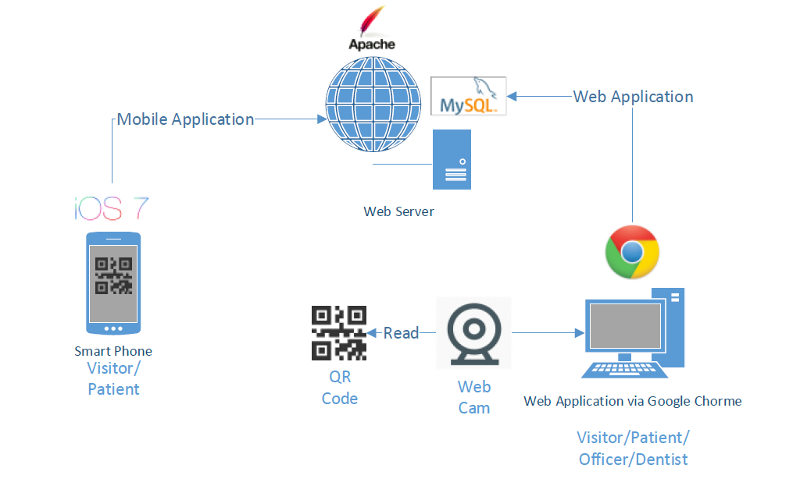

Figure 1: Shows the system architecture of Dental Clinic Services System

**Smart Phone:** This part will use Html language to create a hybrid mobile application from Phone Gap and PhoneGap Build. We design to create only a mobile application for iOS.User who not login to the system will call as a visitor. Visitor can view all appointment of the clinic, cost estimation, view promotion, dental clinic information and basic knowledge of dental treatment. User who uses the patientID and password to login will called patient, patient can view their appointment schedule and can receive QR Code for identifying themself at the clinic, consult with their dentist, and can use all services provided for visitor.

**QR Code:** QR Code uses to identified the patient at the clinic. The QR code contains the patientID for webcam to read QR Code.

**Web Cam:** Web cam is use to read the QR Code, and the system will check appointment and manage the queue for patient.

Web Application: Web application can be used by all type of user(patient, officer, and dentist). Patient can use all services in the web application as well as the mobile application. Officer can use web application to manage the appointment, dentist account, patient account, al so manage all the data in web application an mobile application such as can change the price in cost estimation function and change some information of dental clinic. dentist

**Web Server:** Web server is the server services provided for mobile application and web application link to each other with the same source of data and user.

# Chapter Four: Detail Design

## 4. Detail Design

### 4.1 Class diagram

**4.1.1 DCSS website class diagram**

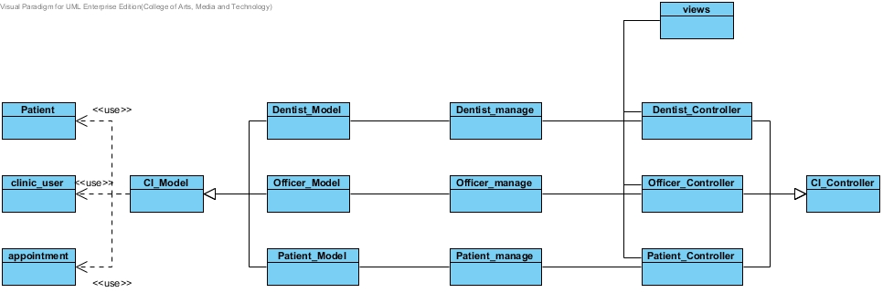

Figure 2: Shows class diagram of Dental Clinic Services System

**4.1.2 DCSS mobile application class diagram**

**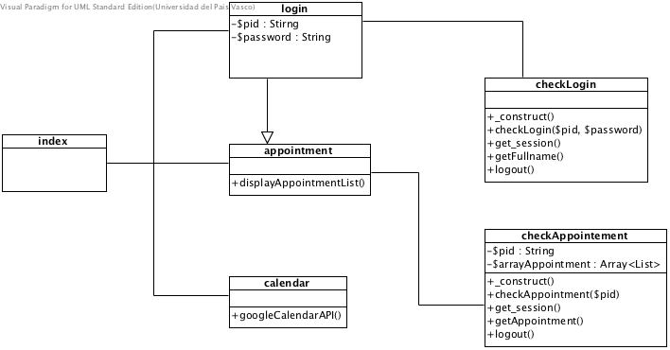**

4.2 Class Diagram Description

4.2.1 Class Diagram Description (DCSS website)

CD-01, URS

Class name: clinic\_user

**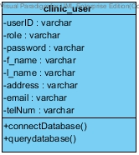**

Property

|  |  |  |  |
| --- | --- | --- | --- |
| ID | Name | Description | Remark |
| 1 | $userID | Identify the userID that store in the database. | Type: varchar |
| 2 | $role | Identify the users’ role such as dentist or officer that store in database | Type: varchar |
| 3 | $password | Identify the users’ password that store in database | Type: varchar |
| 4 | $f\_name | Identify the users’ firstname that store in the database. | Type: varchar |
| 5 | $l\_name | Identify the users’ surname that store in the database. | Type: varchar |
| 6 | $address | Identify the users’ address that store in the database. | Type: varchar |
| 7 | $email | Identify the users’ email that store in the database. | Type: varchar |
| 8 | $telNum | Identify the users’ telephone number that store in the database. | Type: varchar |

Method

|  |  |  |  |
| --- | --- | --- | --- |
| ID | Name | Description | Remark |
| 1 | connectDatabse() | Method uses to connect with the dental clinic database. | - |
| 2 | queryDatabase() | Method uses to query the data from the dental clinic database. | - |

CD-02, URS

Class name: Patient

**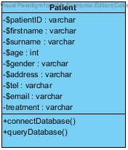**

Property

|  |  |  |  |
| --- | --- | --- | --- |
| ID | Name | Description | Remark |
| 1 | $patientID | Declare variable for identify the patientID that store in the database. | Type: varchar |
| 2 | $firstname | Declare variable for identify the patients’ firstname that store in the database. | Type: varchar |
| 3 | $surname | Declare variable for identify the patients’ surname that store in the database. | Type: varchar |
| 4 | $age | Declare variable for identify the patients’ age that store in the database. | Type: int |
| 5 | $gender | Declare variable for identify the patients’ gender that store in the database. | Type: varchar |
| 6 | $address | Declare variable for identify the patient’s address that store in the database. | Type: varchar |
| 7 | $tel | Declare variable for identify the patients’ tel that store in the database. | Type: varchar |
| 8 | $email | Declare variable for identify the patients’email that store in the database. | Type: varchar |
| 9 | $treatment | Declare variable for identify the patients’ dental treatment that store in the database. | Type: varchar |

Method

|  |  |  |  |
| --- | --- | --- | --- |
| ID | Name | Description | Remark |
| 1 | connectDatabse() | Method uses to connect with the dental clinic database. | - |
| 2 | queryDatabase() | Method uses to query the data from the dental clinic database. | - |

CD-03, URS

Class name: Patient\_Model

**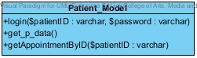**

Property

|  |  |  |  |
| --- | --- | --- | --- |
| ID | Name | Description | Remark |
| - | - | - | - |

Method

|  |  |  |  |
| --- | --- | --- | --- |
| ID | Name | Description | Remark |
| 1 | login($patientID:varchar,$password:varchar) | Method uses to login for patient. | - |
| 2 | get\_p\_data() | Method use to get the patients’ data from database | - |
| 3 | getAppointmentByID($patientID:varchar) | Method uses to get the appointments’ data from database | - |

CD-04,URS

Class name: Patient\_Controller

**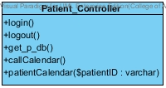**

Property

|  |  |  |  |
| --- | --- | --- | --- |
| ID | Name | Description | Remark |
| - | - | - | - |

Method

|  |  |  |  |
| --- | --- | --- | --- |
| ID | Name | Description | Remark |
| 1 | login() | Method uses to login for patient. | - |
| 2 | logout() | Method uses to logout for patient. | - |
| 3 | get\_p\_db() | Method uses to get patients’ data from database | - |
| 4 | callCalendar() | Method uses to call calendar page |  |
| 5 | patientCalendar() | Method uses to call their own calendar | - |

CD-05, URS

Class name: Officer

**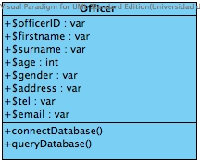**

Property

|  |  |  |  |
| --- | --- | --- | --- |
| ID | Name | Description | Remark |
| 1 | $officerID | Declare variable for identify the officerID that store in the database. | Type: varchar |
| 2 | $firstname | Declare variable for identify the officers’ firstname that store in the database. | Type: varchar |
| 3 | $surname | Declare variable for identify the officers’ surname that store in the database. | Type: varchar |
| 4 | $age | Declare variable for identify the officers’ age that store in the database. | Type: int |
| 5 | $gender | Declare variable for identify the officers’ gender that store in the database. | Type: varchar |
| 6 | $address | Declare variable for identify the officers’ address that store in the database. | Type: varchar |
| 7 | $tel | Declare variable for identify the officers’ tel that store in the database. | Type: varchar |
| 8 | $email | Declare variable for identify the officers’email that store in the database. | Type: varchar |

Method

|  |  |  |  |
| --- | --- | --- | --- |
| ID | Name | Description | Remark |
| 1 | connectDatabse() | Method uses to connect with the dental clinic database. | - |
| 2 | queryDatabase() | Method uses to query the data from the dental clinic database. | - |

CD-06,URS

Class name: Officer\_Model

****

Property

|  |  |  |  |
| --- | --- | --- | --- |
| ID | Name | Description | Remark |
| - | - | - | - |

Method

|  |  |  |  |
| --- | --- | --- | --- |
| ID | Name | Description | Remark |
| 1 | login($userID:varcahar) | Method uses to login for patient. | - |
| 2 | get\_db() | Method uses to get all dentists’ data and officers’ data from database | - |
| 3 | get\_p\_data() | Method uses to get all patients’ data from database | - |
| 4 | getDataByID($userID:varchar) | Method uses to get data of dentist by using userID | - |
| 4 | get\_p\_DataByID($pateintID:varchar) | Method uses to get data of patient by using patientID | - |
| 5 | addnew($data:array[]) | Method uses to add new patient to the database | - |
| 6 | update($data:array[]) | Method uses to update patients’ data to database | - |
| 8 | delete($patientID:varchar) | Method uses to delete patient from database by using of patientID | - |
| 9 | addnew\_d($data:array[]) | Method uses to add new dentist to the database | - |
| 10 | d\_update($data:array[]) | Method uses to update dentists’ data to database | - |
| 11 | get\_appointment() | Method uses to get data of appointments from database | - |
| 12 | make\_new($data:varchar) | Method uses to add new appointment to database | - |
| 13 | appointment\_update($data:varchar) | Method uses to update appointments’ data to database | - |
| 14 | app\_delete($appointmentID:int) | Method uses to delete appointments’ data from database | - |
| 15 | getAppointmentByID($patientID:varchar) | Method uses to get appointments’ data from database by using patientID | - |
| 16 | getAppointmentByUserID($userID:varchar) | Method uses to get appointments’ data from database by using userID | - |
| 17 | get\_p\_calendar() | Method uses to get all appointments’ data from database | - |
| 18 | get\_d\_calendar() | Method uses to get all appointments’ data from database | - |

CD-07,URS

Class name: Officer\_Controller

**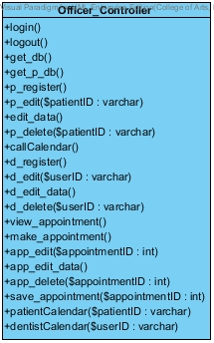**

Property

|  |  |  |  |
| --- | --- | --- | --- |
| ID | Name | Description | Remark |
| - | - | - | - |

Method

|  |  |  |  |
| --- | --- | --- | --- |
| ID | Name | Description | Remark |
| 1 | login() | Method uses to login for patient. | - |
| 2 | logout() | Method uses to logout for patient. | - |
| 3 | get\_db() | Method uses to get all dentists’ data and officers’ data from database | - |
| 4 | get\_p\_db() | Method uses to get all patients’ data from database. | - |
| 5 | p\_register() | Method uses to register new patient to the system | - |
| 6 | p\_edit($patientID:varchar) | Method uses to call patient edit page with appointment data | - |
| 7 | edit\_data() | Method uses to save the edit data of patient to the database | - |
| 8 | p\_delete($patientID:varchar) | Method uses to delete any patient from the system and database | - |
| 9 | callCalendar() | Method uses to call calendar from google calendar | - |
| 10 | d\_register() | Method uses to register new dentist to the system | - |
| 11 | d\_edit($userID:varchar) | Method uses to call dentist edit page with dentist data | - |
| 12 | d\_edit\_data() | Method uses to save the edit data of dentist to the database | - |
| 13 | d\_delete($userID:varchar) | Method uses to delete any dentist from the system and database | - |
| 14 | view\_appointment() | Method uses to get all appointment data to view | - |
| 15 | make\_appointment() | Method uses to make new appointment | - |
| 16 | app\_edit($appointment:varchar) | Method uses to call appointment edit page with appointment data | - |
| 17 | app\_edit\_data() | Method uses to save the edit data of appointment to the database | - |
| 18 | app\_delete($appointmentID:varchar) | Method uses to delete any appointment from the system and database | - |
| 19 | save\_appointment($appointmentID:varchar) | Method uses to save appointment to google calendar | - |
| 20 | patientCalendar($patientID:varchar) | Method uses to get patients’ calendar by using patientID | - |
| 21 | dentistCalendar($userID:varchar) | Method uses to get dentists’ calendar by using userID | - |

CD-08,URS

Class name: Dentist

**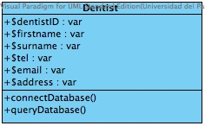**

Property

|  |  |  |  |
| --- | --- | --- | --- |
| ID | Name | Description | Remark |
| 1 | $dentistID | Declare variable for identify the dentistID that store in the database. | Type: varchar |
| 2 | $firstname | Declare variable for identify the dentists’ firstname that store in the database. | Type: varchar |
| 3 | $surname | Declare variable for identify the dentists’ surname that store in the database. | Type: varchar |
| 4 | $address | Declare variable for identify the dentists’ address that store in the database. | Type: varchar |
| 5 | $tel | Declare variable for identify the dentists’ tel that store in the database. | Type: varchar |
| 6 | $email | Declare variable for identify the dentists’email that store in the database. | Type: varchar |

Method

|  |  |  |  |
| --- | --- | --- | --- |
| ID | Name | Description | Remark |
| 1 | connectDatabse() | Method uses to connect with the dental clinic database. | - |
| 2 | queryDatabase() | Method uses to query the data from the dental clinic database. | - |

CD-9,URS

Class name: Dentist\_Model

**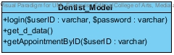**

Property

|  |  |  |  |
| --- | --- | --- | --- |
| ID | Name | Description | Remark |
| - | - | - | - |

Method

|  |  |  |  |
| --- | --- | --- | --- |
| ID | Name | Description | Remark |
| 1 | login($userID:varchar,$password:varchar) | Method uses to login for dentist. | - |
| 2 | get\_d\_data() | Method uses to get dentist data from database | - |
| 3 | getAppointmentByID($userID:varchar) | Method uses to get appointment by using userID | - |

CD-10,URS

Class name: Dentist\_Controller

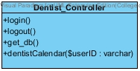

Property

|  |  |  |  |
| --- | --- | --- | --- |
| ID | Name | Description | Remark |
| - | - | - | - |

Method

|  |  |  |  |
| --- | --- | --- | --- |
| ID | Name | Description | Remark |
| 1 | login() | Method uses to login for dentist. | - |
| 2 | logout() | Method uses to logout for dentist. | - |
| 3 | get\_db() | Method uses to get dentist data from database | - |
| 4 | dentistCalendar($userID:varchar) | Method uses to get dentist calendar by userID | - |

CD-11,URS

Class name: Patient manage

**C:\Users\SONY\Desktop\senior project\progress1\usecase\cd.jpg\patient_manage.jpg**

Property

|  |  |  |  |
| --- | --- | --- | --- |
| ID | Name | Description | Remark |
| - | - | - | - |

Method

|  |  |  |  |
| --- | --- | --- | --- |
| ID | Name | Description | Remark |
| 1 | login($patientID:varchar,$password:varchar) | Method uses to login for patient. | - |
| 2 | getCalendarByPID($patientID:varchar) | Method uses to get patients’ calendar by using patientID | - |

CD-12,URS

Class name: Officer manage

**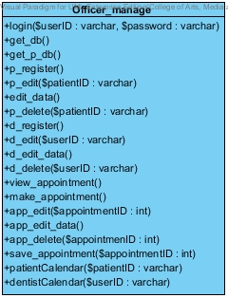**

Property

|  |  |  |  |
| --- | --- | --- | --- |
| ID | Name | Description | Remark |
| - | - | - | - |

Method

|  |  |  |  |
| --- | --- | --- | --- |
| ID | Name | Description | Remark |
| 1 | login($userID:varcahar) | Method uses to login for patient. | - |
| 2 | get\_db() | Method uses to get all dentists’ data and officers’ data from database | - |
| 3 | get\_p\_data() | Method uses to get all patients’ data from database | - |
| 4 | getDataByID($userID:varchar) | Method uses to get data of dentist by using userID | - |
| 4 | get\_p\_DataByID($pateintID:varchar) | Method uses to get data of patient by using patientID | - |
| 5 | addnew($data:array[]) | Method uses to add new patient to the database | - |
| 6 | update($data:array[]) | Method uses to update patients’ data to database | - |
| 8 | delete($patientID:varchar) | Method uses to delete patient from database by using of patientID | - |
| 9 | addnew\_d($data:array[]) | Method uses to add new dentist to the database | - |
| 10 | d\_update($data:array[]) | Method uses to update dentists’ data to database | - |
| 11 | get\_appointment() | Method uses to get data of appointments from database | - |
| 12 | make\_new($data:varchar) | Method uses to add new appointment to database | - |
| 13 | appointment\_update($data:varchar) | Method uses to update appointments’ data to database | - |
| 14 | app\_delete($appointmentID:int) | Method uses to delete appointments’ data from database | - |
| 15 | getAppointmentByID($patientID:varchar) | Method uses to get appointments’ data from database by using patientID | - |
| 16 | getAppointmentByUserID($userID:varchar) | Method uses to get appointments’ data from database by using userID | - |
| 17 | get\_p\_calendar() | Method uses to get all appointments’ data from database | - |
| 18 | get\_d\_calendar() | Method uses to get all appointments’ data from database | - |

CD-13,URS

Class name: Dentist manage

**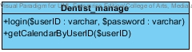**

Property

|  |  |  |  |
| --- | --- | --- | --- |
| ID | Name | Description | Remark |
| - | - | - | - |

Method

|  |  |  |  |
| --- | --- | --- | --- |
| ID | Name | Description | Remark |
| 1 | login($patientID:varchar,$password:varchar) | Method uses to login for patient. | - |
| 2 | getCalendarByUserID($patientID:varchar) | Method uses to get dentists’ calendar by using dentistID | - |

4.2.2 Class Diagram Description (DCSS mobile application)

CD-014,URS

Class name: login

**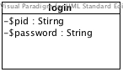**

Property

|  |  |  |  |
| --- | --- | --- | --- |
| ID | Name | Description | Remark |
| 1 | $pid | Declare variable for identify the patientID that store in the database. | Type:Stirng |
| 2 | $password | Declare variable for identify the passoword that store in the database. | Type:Stirng |

Method

|  |  |  |  |
| --- | --- | --- | --- |
| ID | Name | Description | Remark |
| - | - | - | - |

CD-015,URS

Class name: checkLogin

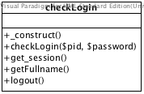

Property

|  |  |  |  |
| --- | --- | --- | --- |
| ID | Name | Description | Remark |
| - | - | - | - |

Method

|  |  |  |  |
| --- | --- | --- | --- |
| ID | Name | Description | Remark |
| 1 | \_construct() | Method uses to create DB object for connecting with database | - |
| 2 | checkLogin($pid,$password) | Method uses to check patientID and password are match with the database | - |
| 3 | get\_session() | Method uses to store the patientID and password as a session | - |
| 4 | getFullname() | Method uses to select firstname and lastname of patient that in the database to display his/her name on the page after login | - |
| 5 | logout() | Method uses to destroy session after user select and it will redirect to index page | - |

CD-016,URS

Class name: checkAppointment

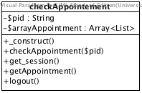

Property

|  |  |  |  |
| --- | --- | --- | --- |
| ID | Name | Description | Remark |
| 1 | $pid | Declare variable for identify the patientID that store in the database. | Type:Stirng |
| 2 | $arrayAppointment | Declare variable for get the appointment information from the database | Type:Array<List> |

Method

|  |  |  |  |
| --- | --- | --- | --- |
| ID | Name | Description | Remark |
| 1 | \_construct() | Method uses to create DB object for connecting with database | - |
| 2 | checkLogin($pid) | Method uses to check patientID and the database | - |
| 3 | get\_session() | Method uses to store the patientID as a session | - |
| 4 | getAppointment() | Method uses to select appointment information using patientID session to identify patients’ appointment | - |
| 5 | logout() | Method uses to destroy session after user select and it will redirect to index page | - |

CD-017,URS

Class name: calendar



Property

|  |  |  |  |
| --- | --- | --- | --- |
| ID | Name | Description | Remark |
| - | - | - | - |

Method

|  |  |  |  |
| --- | --- | --- | --- |
| ID | Name | Description | Remark |
| 1 | googleCalendarAPI() | Method uses google calendar API to view the appointment in the google calendar | - |

# Chapter Five: Sequence Diagram

## 5. Sequence Diagram

**5.1 DCSS website Sequence Diagram**

**SD-01: Login**

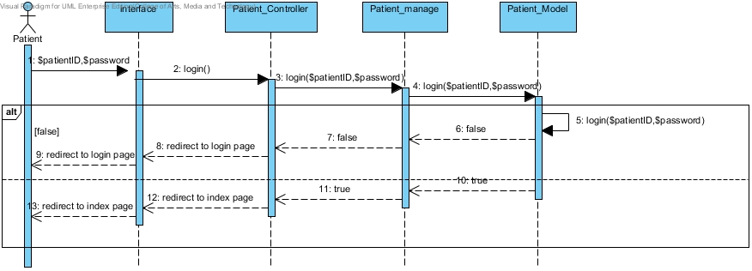

Figure 3: Patient Login

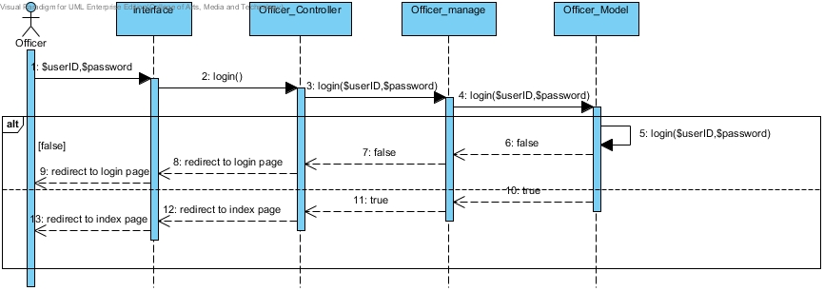

Figure 4: Officer Login

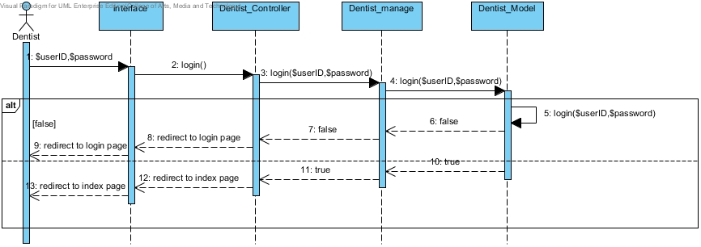

Figure 5: Dentist login

**SD-02: Logout**

**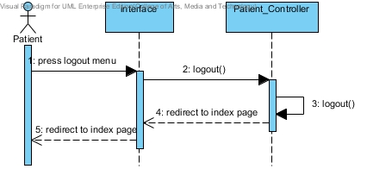**

Figure 6: Patient logout

**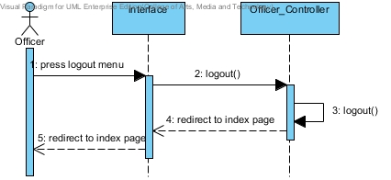**

Figure 7: Officer logout

**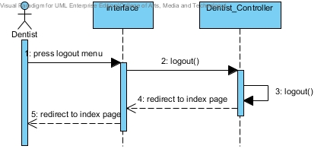**

Figure 8: Dentist Logout

**SD-03: View dental clinic calendar**

**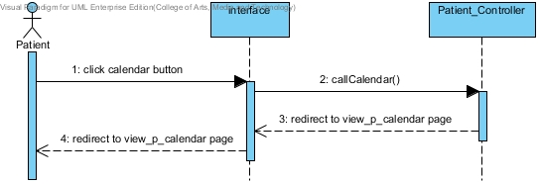**

Figure 9: Patient view dental clinic calendar

**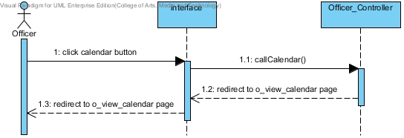**

Figure 10: Officer view dental clinic calendar

**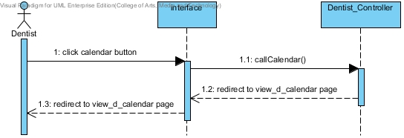**

Figure 11: Dentist view dental clinic calendar

**SD-04: View his/her own appointment**

**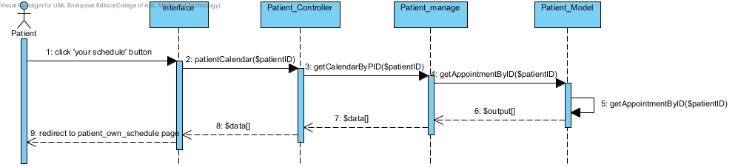**

Figure 12: Patient can view his/her own appointment

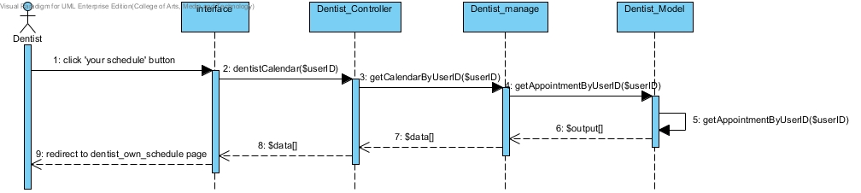

Figure 13: Dentist can view his/her own appointment

**SD-05: View all appointment in dental clinic**

**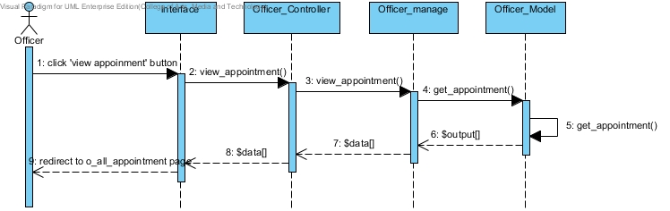**

Figure 14:Officer can view all appointment in dental clinic

**SD-06: Create patient account**

**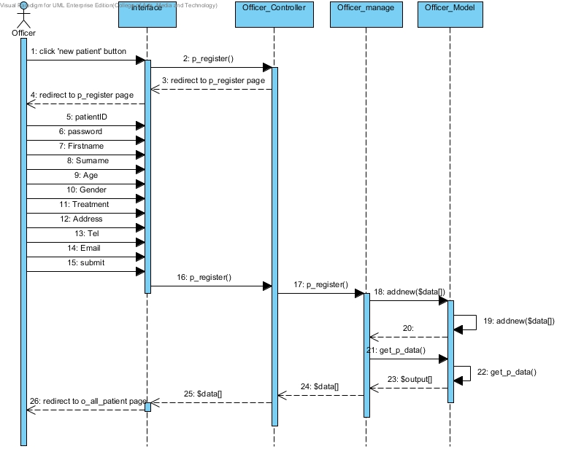**Figure 15: Officer can create new patient account and the list of all patients show after register.

**SD-07: Create create dentist account**

**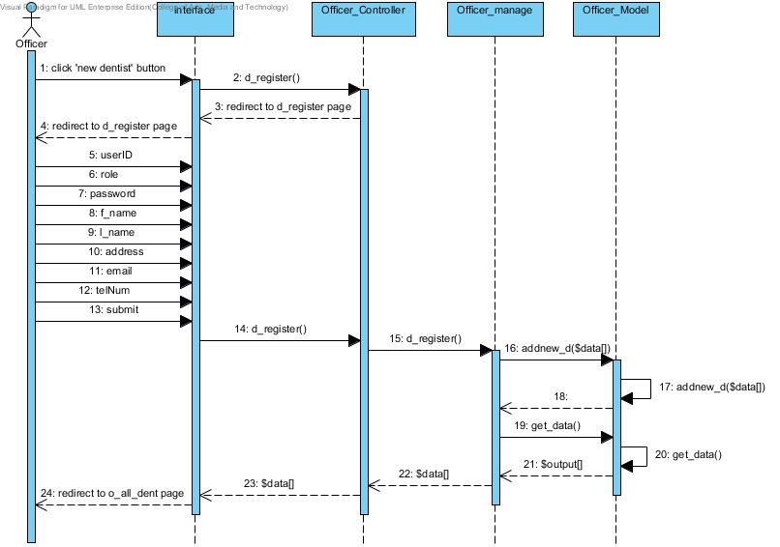**

Figure 16: Officer can create new dentist account and the list of all clinic user shows after register

**SD-08: View all patients as a list**

**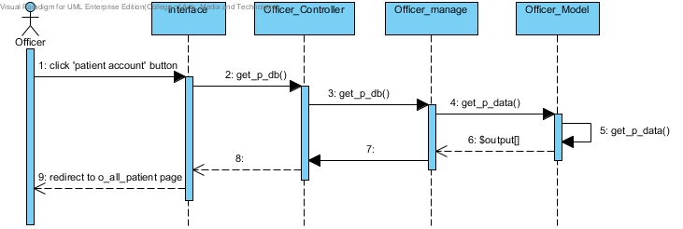**

Figure 17: Officer can view all patients as a list

**SD-09: View all dentist as a list**

**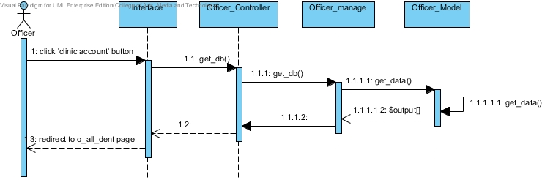**

Figure 18: Officer can view all dentists in the list

**SD-10: Make an appointment**

**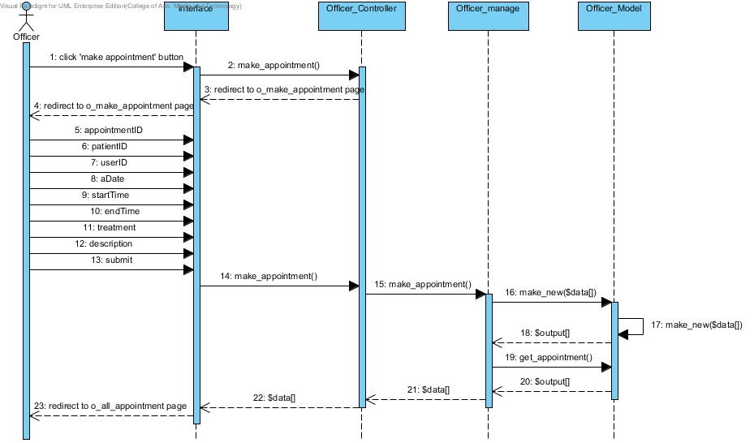**

Figure 19: Officer can add new appointment into the database and it will update in the dental clinic appointment schedule

**SD-11: Edit an appointment**

**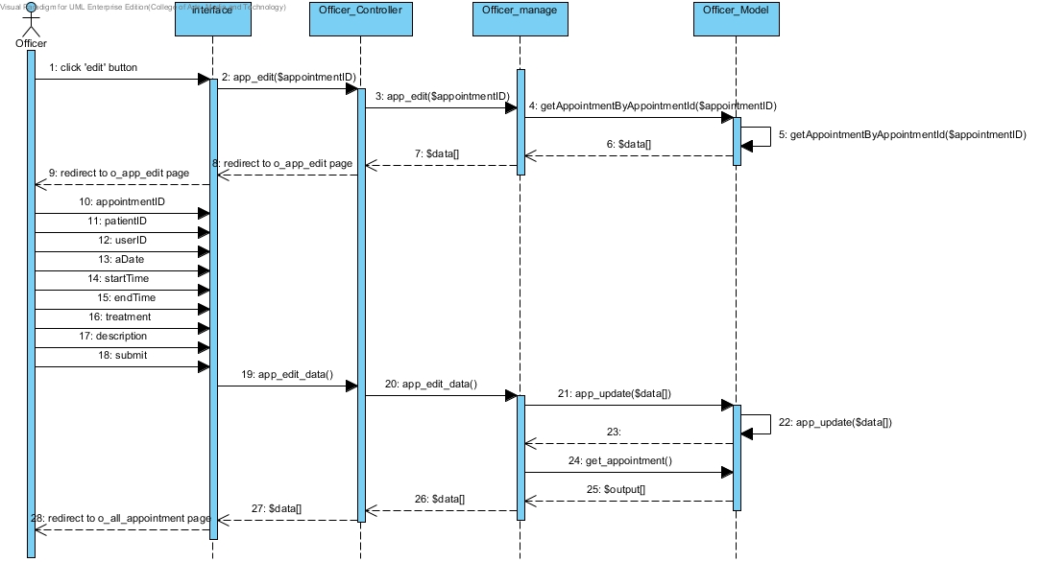**

Figure 20: Officer can edit an appointment into the database and it will update in the dental clinic appointment schedule

**SD-12: Delete an appointment**

**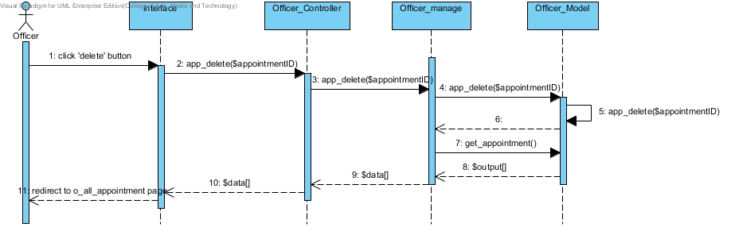**

Figure 21: Officer can delete an appointment into the database and it will update in the dental clinic appointment schedule

**SD-13: Edit patients’ account**

**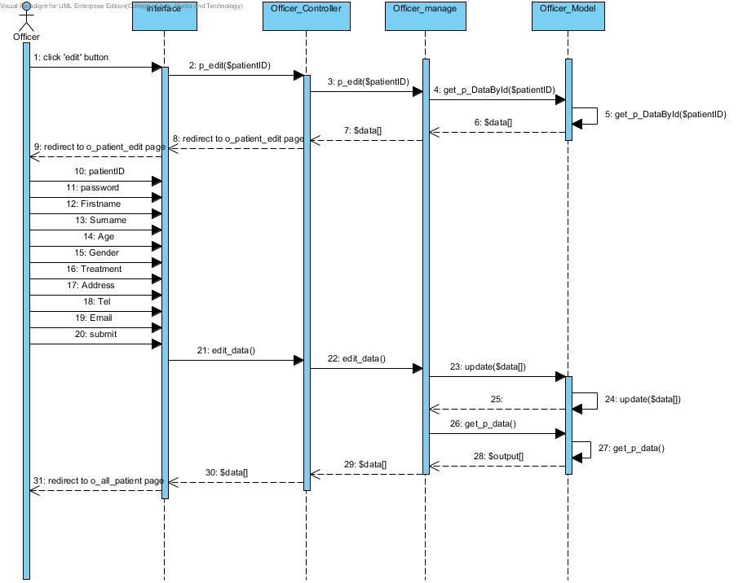**

Figure 22: Officer can edit patients’ account and the list of all patients shows after edit

**SD-14: Edit dentists’ account**

**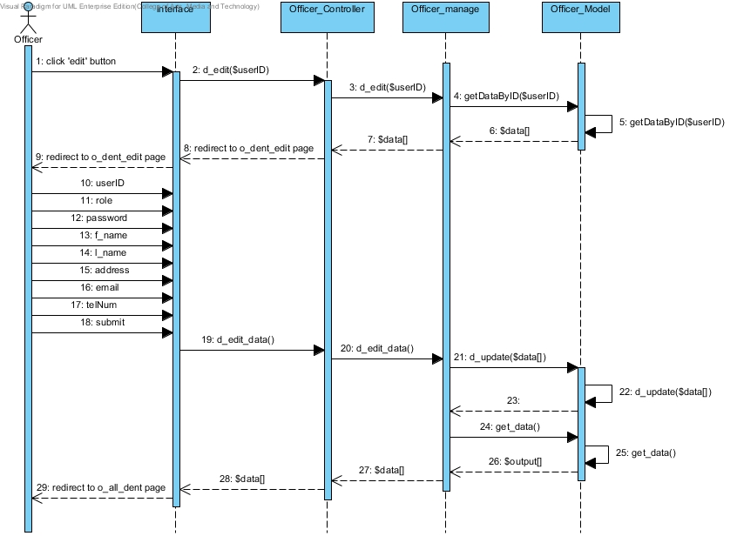**

Figure 23: Officer can edit dentists’ account and the list of all clinic users shows after edit

**SD-15: Delete patients’ account**

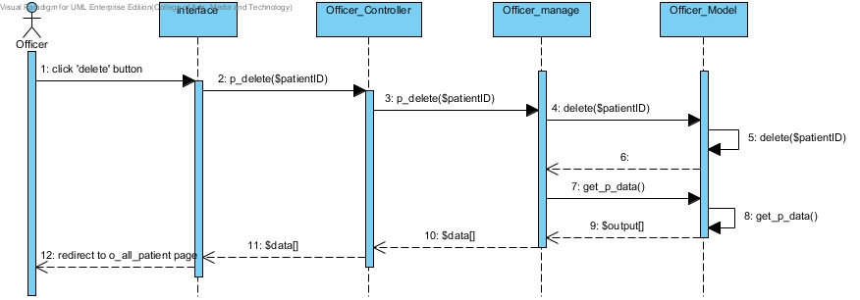

Figure 24: Officer can delete patients’ account and the list of all patients shows after edit

**SD-16: Delete dentists’ account**

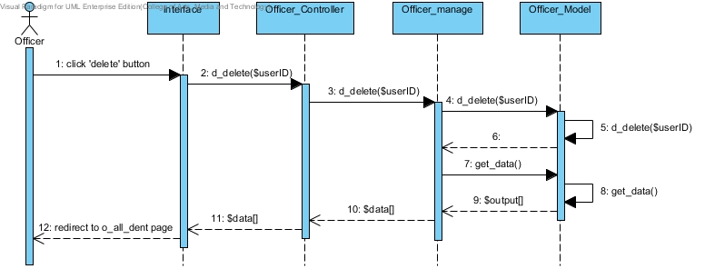

Figure 25: Officer can delete dentists’ account and the list of all dentists shows after edit

**SD-17: Save appointment to Google Calendar**

**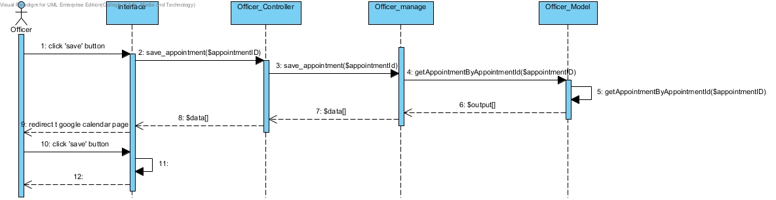**

Figure 26: Officer can save an appointment to Google Calendar by using dental clinic services system Google account

**5.2 DCSS mobile application Sequence Diagram**

**SD-18: Login to the mobile application**

**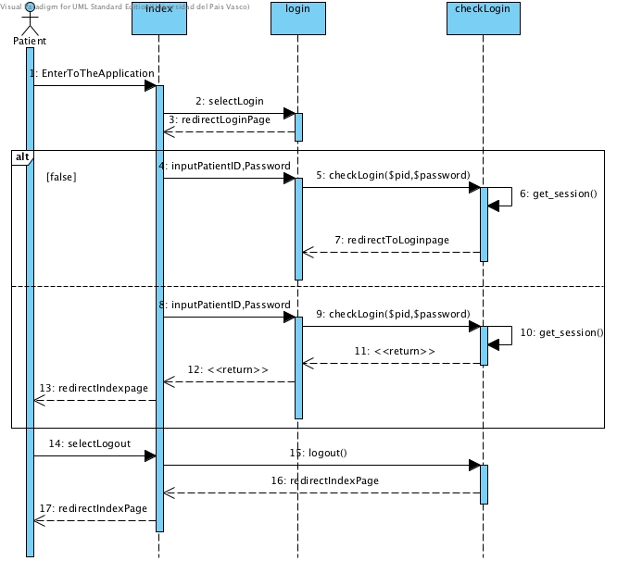**

Figure 27: Patient can login to the mobile application

**SD-19: View his/her own appointment**

**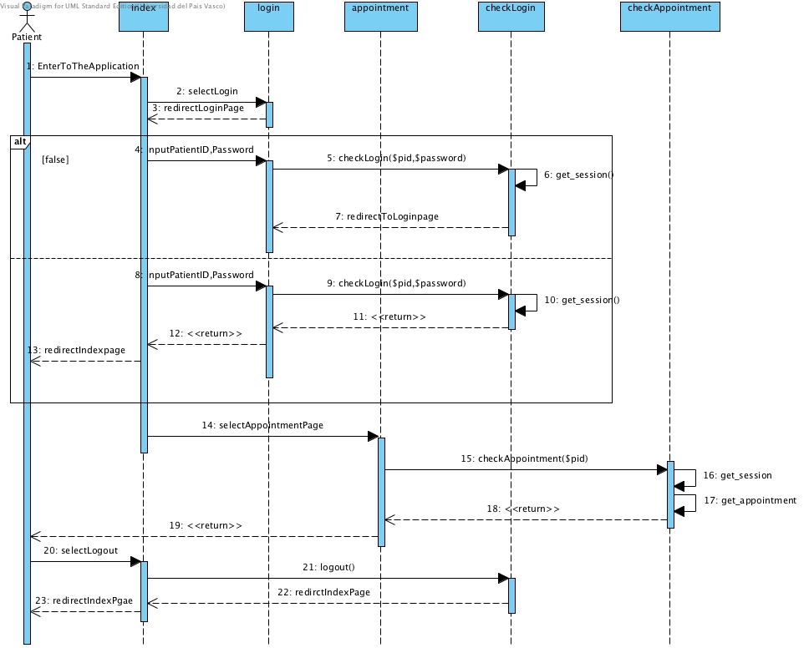**

Figure 28: Patient can view his/her appointment after login if user does not login the appointment will not diaplay

**SD-20: View appointment in google calendar**

**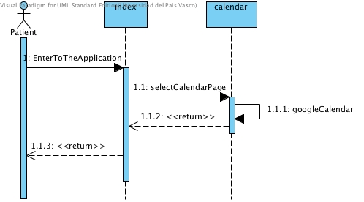**

Figure 29: Patient can view all appointment in google calendar

# Chapter Six: User Interface Design

## 6. User Interface Design

**6.1 Web design**

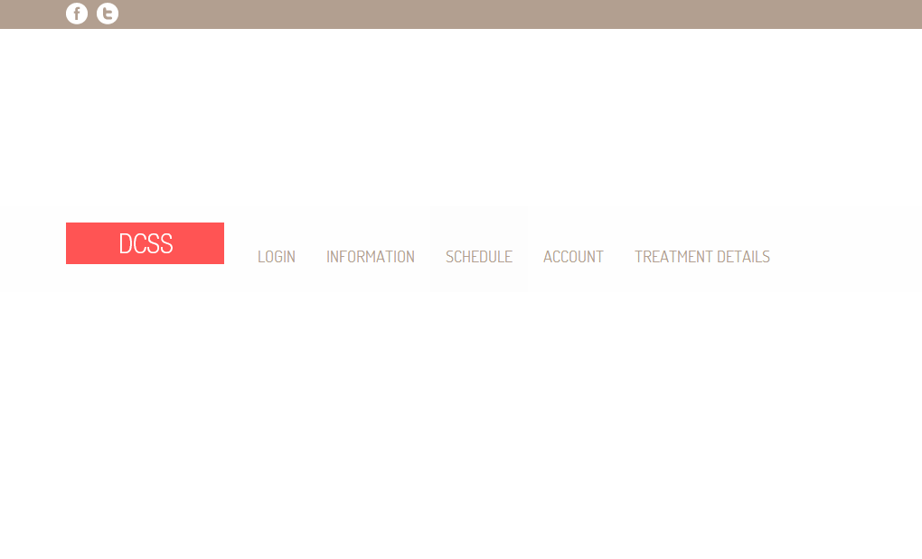

Figure 30: Shows the index page of website

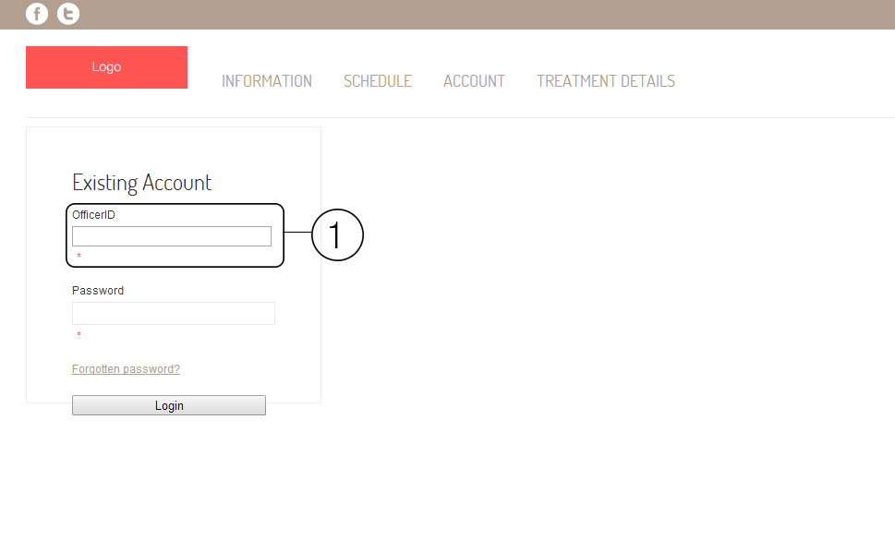

Figure 31: Shows the login page of the website. The area number 1 is the field of input userID and patientID. In officer login page will show as OfficerID, in patient login page will show as PatientID, and in dentist login page will show as DentistID.

**Patient**

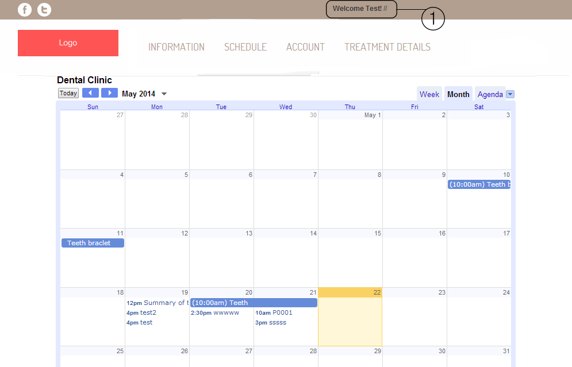

Figure 32: Shows the schedule of dental clinic from google calendar. The area number 1 will shows the name of patient.

**Officer**

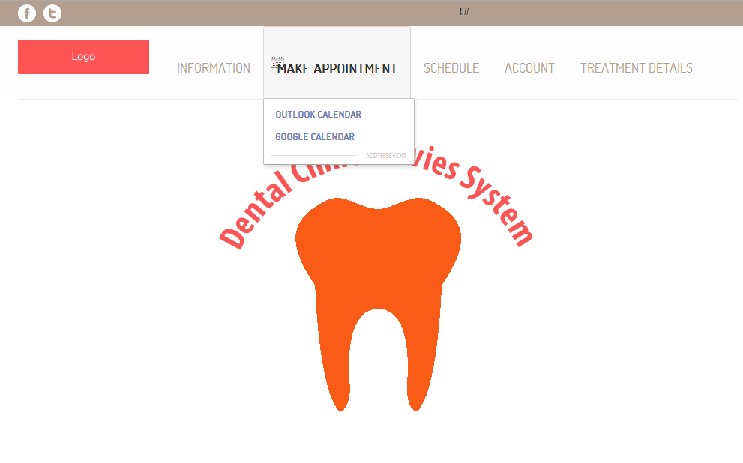

Figure 33: Shows the officer index page after officer login. Officer can make appointment google calendar, view schedule, and manage account.

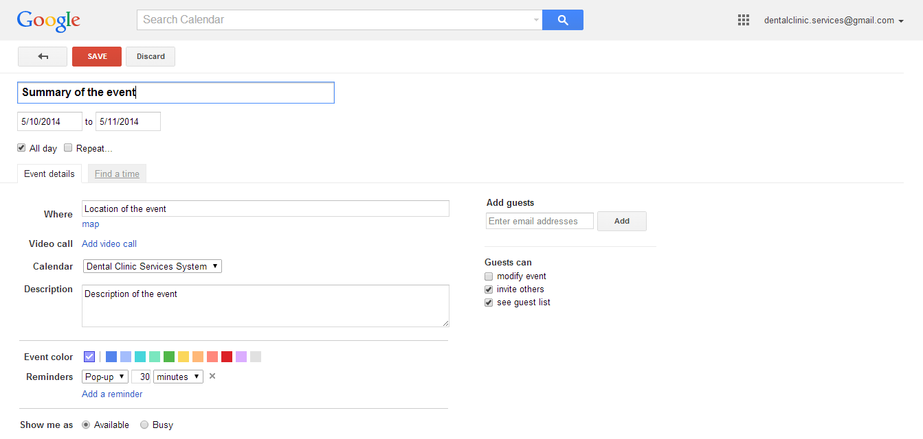

Figure 34: Shows page of google calendar to add the appointment to dental clinic calendar.

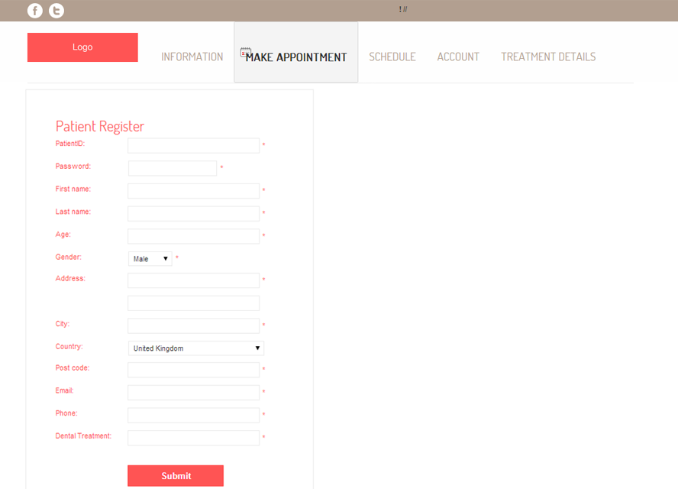

Figure 35: Shows the patient registration page.

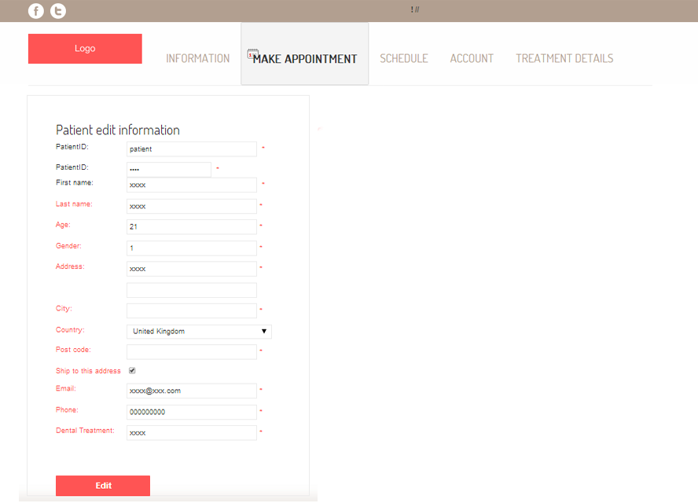

Figure 36: Shows the edit patients’ details page.

**6.2 Mobile application design**

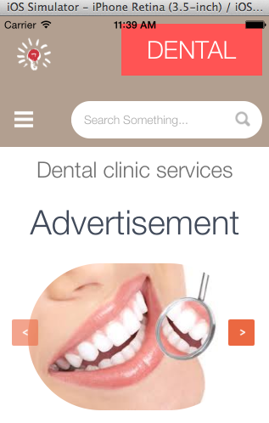

Figure 37: Mobile application home page

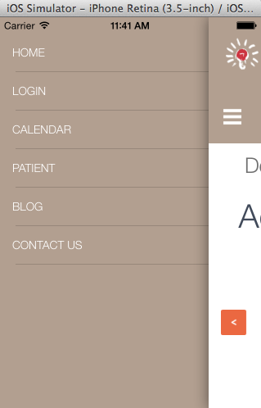

Figure 38: Mobile application menu

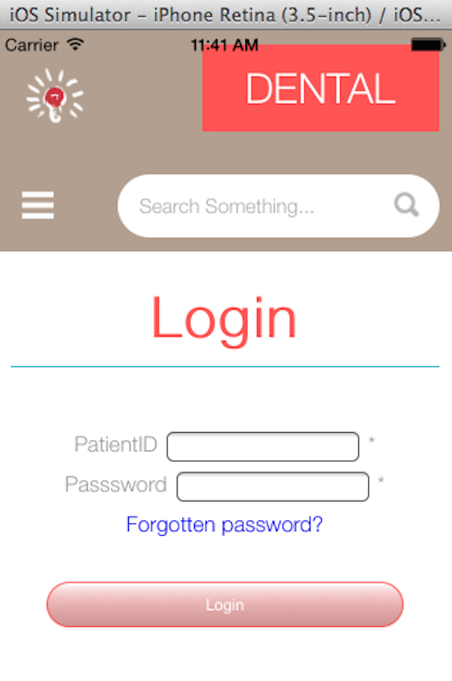

Figure 39: Login page for patient

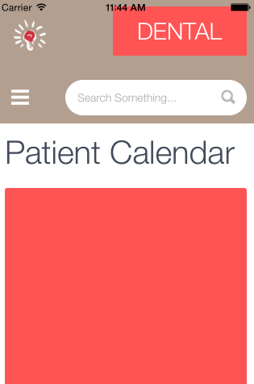

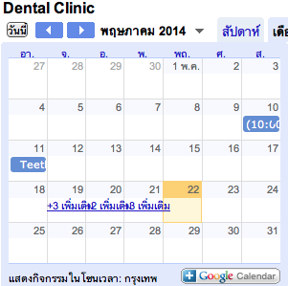

Figure 40: Patient Calendar after select patient

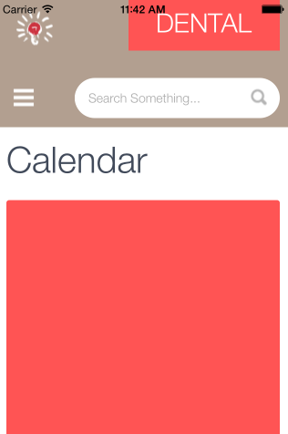



Figure 41: Dental clinic calendar